# LAB # 09

**Objective:** Study the sine wave on an oscilloscope and determine its peak, peak to peak, r.m.s. and average values of voltage.

**Equipment:**

* + Function generator
  + Oscilloscope
  + Digital Multimeter (DMM)
  + Resistor (appropriate value for current measurement)
  + Connecting wires and probes

**Theory:**

A sine wave is a periodic waveform that can be described mathematically by the function

***V(t) = Vmsin(ωt)***

where Vm is the peak voltage and ω is the angular frequency.

1. **Peak Value (Vp)**: The maximum value (positive or negative) of the sine wave.
2. **Peak-to-Peak Value (Vpp)**: The difference between the maximum positive and maximum negative values of the sine wave.
3. **RMS Value (Vrms)**: The effective value of the sine wave, given by ***Vrms = Vp / √2***
4. **Average Value**: For a full sine wave over one complete cycle, the average value is zero. For half- wave rectified sine wave, it is ***Vavg =*** 𝟐𝑽𝒑

∏

**Procedure:**

* 1. **Voltage Measurement:**
     1. **Setup the Function Generator and Oscilloscope:**
        + Connect the output of the function generator to the input of the oscilloscope.
        + Set the function generator to produce a sine wave with a known frequency (e.g., 1 kHz) and amplitude (e.g., 5V peak).
     2. **Observing the Sine Wave:**
        + Turn on the oscilloscope and adjust the time base and voltage settings to display one or more cycles of the sine wave on the screen.
        + Use the oscilloscope's measurement tools or cursors to measure the peak value (Vp) and peak-to- peak value (Vpp) of the sine wave.
     3. **Calculating RMS and Average Values:**
        + Calculate the RMS value using ***Vrms=Vp / √2***
        + Since the average value of a full sine wave over one cycle is zero, confirm this by using the oscilloscope's math functions if available.

**Observation:**

1. **Voltage Measurements**

|  |  |  |
| --- | --- | --- |
| **Parameter** | **Theoretical Value** | **Measured Value** |
| Peak Voltage (Vp) |  |  |
| Peak-to-Peak Voltage (Vpp) |  |  |
| RMS Voltage (Vrms) |  |  |
| Average Voltage (Half Wave) |  |  |

**Conclusion:**

Summarize the observations, comparing the theoretical values with the measured ones. Discuss any sources of error and suggest improvements for future experiments.

**Safety Precautions:**

* Ensure all connections are secure to avoid short circuits.
* Do not exceed the voltage and current ratings of the equipment.
* Handle the oscilloscope probes carefully to avoid damaging them.

**Waveform:**

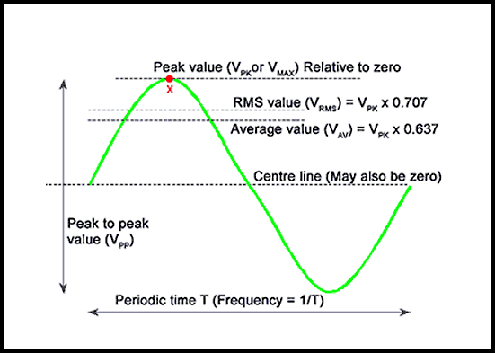

## POST LAB:

1. What type of signal should be selected on the function generator to produce a sine wave?
2. How do you set the frequency to 1kHz on a function generator?
3. How can you set the amplitude to 2V peak-to-peak on a function generator?